MEETING NOTICE

Sub: Meeting of all HOD’s/Incharge and members of the Disciplinary Committee on 16-04-2026.

All HOD’s/Incharge and members of the Disciplinary Committee are hereby informed that an urgent meeting is scheduled as under:

Date: 16-04-2026 (Thursday)
Time: 2:30 PM sharp
Venue: Principal’s Office.

All are directed to attend the meeting on time.
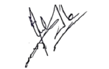

No: KGP/Estt/2026/119
Dated:16-04-2026

Principal
Kashmir Government Polytechnic College
Srinagar

